Task 5
class Solution {
public int myAtoi(String s) {

int i = 0;
int n = s.length();

// Step 1: Skip leading spaces
while (i < n && s.charAt(i) == ' ') {
i++;
}

// Step 2: Check sign
int sign = 1;

if (i < n && s.charAt(i) == '-') {
sign = -1;
i++;
} else if (i < n && s.charAt(i) == '+') {
i++;
}

// Step 3: Convert digits
int result = 0;

while (i < n && Character.isDigit(s.charAt(i))) {

int digit = s.charAt(i) - '0';

// Step 4: Check overflow
if (result > (Integer.MAX_VALUE - digit) / 10) {
return sign == 1 ? Integer.MAX_VALUE : Integer.MIN_VALUE;
}

result = result * 10 + digit;
i++;
}

return result * sign;
}
}
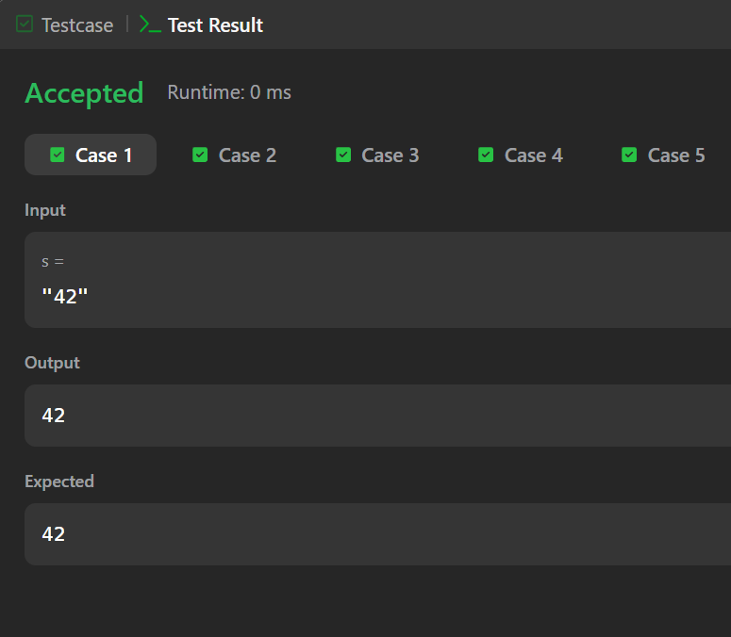
Task 6
import java.io.*;
import java.util.*;

class Result {

public static int alternatingCharacters(String s) {

int count = 0;

for (int i = 1; i < s.length(); i++) {

if (s.charAt(i) == s.charAt(i - 1)) {
count++;
}
}

return count;
}
}

public class Solution {

public static void main(String[] args) throws IOException {

BufferedReader bufferedReader =
new BufferedReader(new InputStreamReader(System.in));

int q = Integer.parseInt(bufferedReader.readLine().trim());

for (int i = 0; i < q; i++) {

String s = bufferedReader.readLine();

int result = Result.alternatingCharacters(s);

System.out.println(result);
}

bufferedReader.close();
}
}
